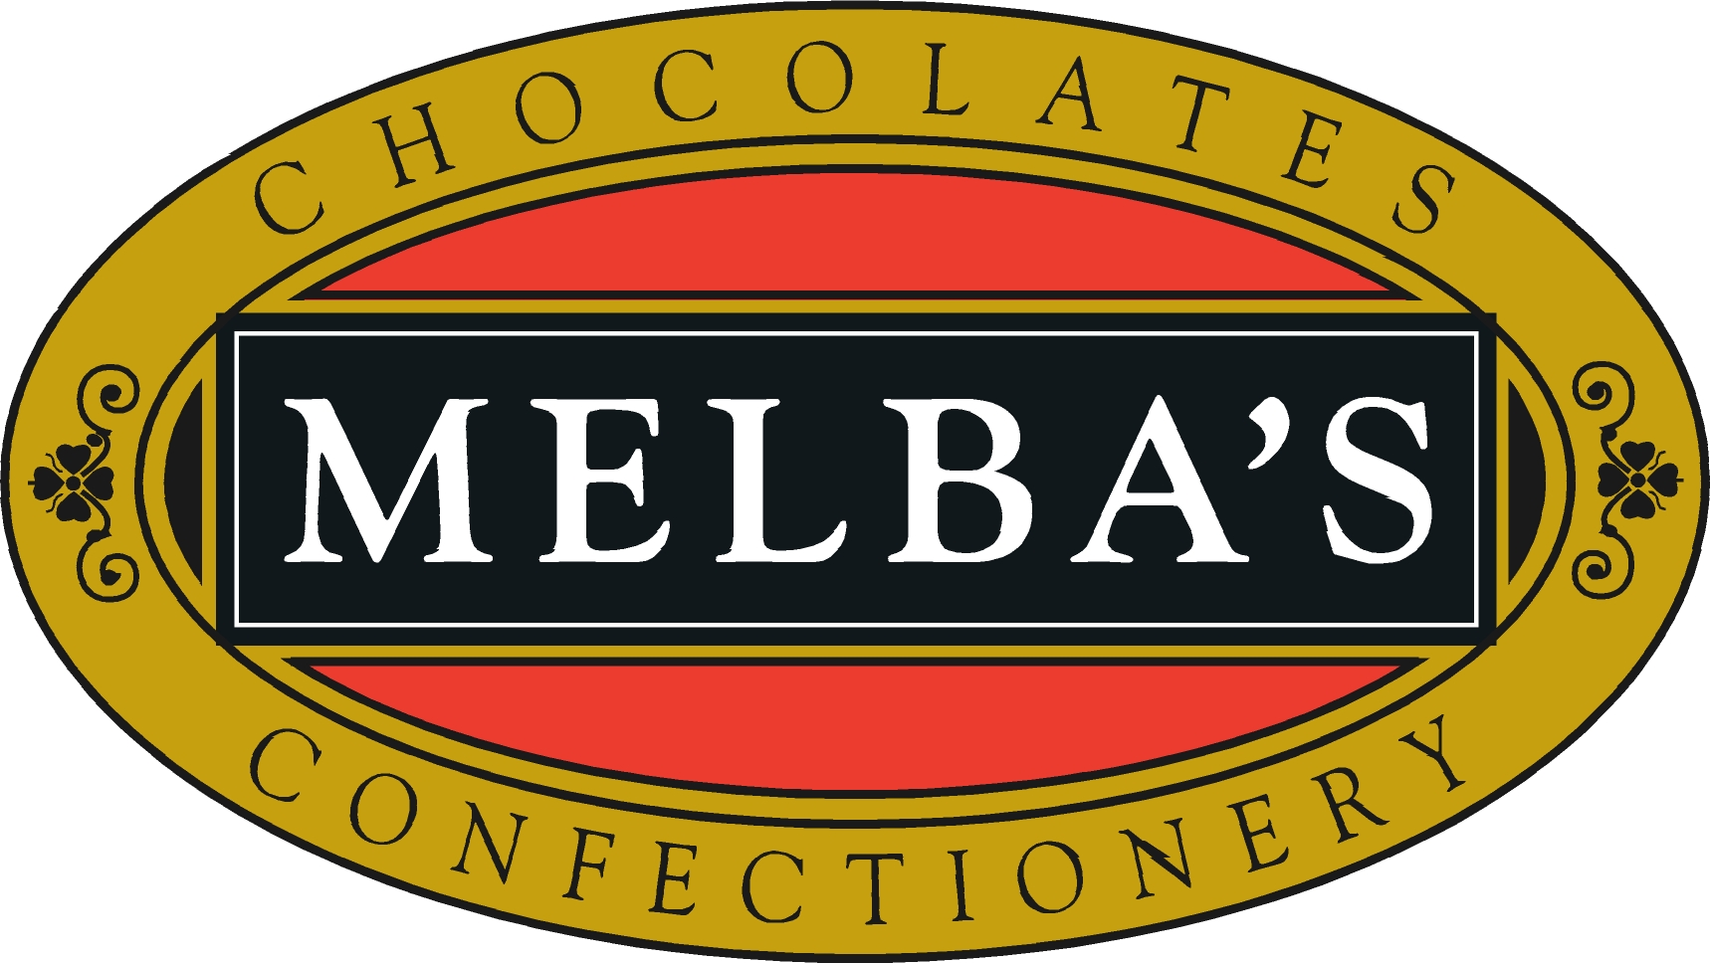

Adelaide Metropolitan Area

Adelaide Fresh Fruiterers
62 Prospect Road
Prospect SA 5082
Ph. 08 8344 8611

Dissels Newsagency
7/186-200 Findon Rd,
Woolworths Complex - Westside
Findon SA 5023
Ph. 08 8445 8733

Happy Valley Newsagency
Kenihans Road
Happy Valley SA 5159
Ph. 08 8381 1266

Liverpool Street Newsagency
40 Liverpool Street
Port Lincoln SA 5606
Ph. 08 8682 1658

Lucias Fine Foods Mitcham
Shop 25, Mitcham Square,
119 Belair Road
Torrens Park SA 5062
Ph. 08 8271 1522

Malvern Paper shop
291 Unley Road
Unley SA 5061
Ph. 08 8373 1138

Newsxpress Blackwood
Shop 5, 10 Coromandel Parade
Blackwood SA 5051
Ph. 08 8278 7117

Northgate Chemplus
Shop 5A Northgate Shopping Centre
Cnr Fosters Road & Folland Ave
Northgate SA 5085
Ph. 08 8261 2199

Port Mall Newsagency
Shop 4, Port Mall Shopping Centre
176 St Vincent Street
Port Adelaide SA 5015
Ph. 08 8447 2961

Royal Adelaide Hospital Newsagency
Main Entry, North Terrace
Adelaide SA 5000
Ph. 08 8222 4709

TC’s Fruit & Veg
Seaford Shopping Centre
Commercial Road
Seacford SA 5169
Ph. 08 8386 3220

Country Areas of South Australia

Ardrossan Newsagency
30 First Street
Ardrossan SA 5571
Ph. 08 8837 3478

Beames Newsagency
26 Agnes Street
Kingston South East SA 5275
Ph. 08 8767 2403

Berri Newsagency
Shop 2A Vaughan Court
Berri SA 5343
Ph. 08 8582 1049

Bordertown Newsagency
54 Woolshed Street
Bordertown SA 5268
Ph. 08 8752 1090

Chapmans Newsagency
11 Commercial Street West
Mount Gambier SA 5290
Ph. 08 8725 3300

Chit Chat Newsagency
Shop 8, Torrens Street
Victor Harbour SA 5211
Ph. 08 8552 3888

Clare Newsagency
263 Main North Road
Clare SA 5453
Ph. 08 8842 2342
Crystal Brook Newsagency
45 Bowman Street
Crystal Brook SA 5523
Ph. 08 8636 2071

Gawler Newsagency
68 Murray Street
Gawler SA 5118
Ph. 08 8522 1465

Goolwa Newsagency
Shop 1, 22 Cadell Street
Goolwa SA 5214
Ph. 08 8555 2152

Millicent Newsagency
5 Glen Street
Millicent SA 5280
Ph. 08 8733 2461

Murray Bridge Newsagency
29 Bridge Street
Murray Bridge SA 5253
Ph. 08 8532 1111

Nairne Pharmacy
64 Main Road
Nairne SA 5252
Ph. 08 8388 6422

Port Vincent Newsagency
6 Main Street
Port Vincent SA 5581
Ph. 08 8853 7078
Riverton Newsagency
36 Torrens Road
Riverton SA 5412
Ph. 08 8847 2037

Rivoli Bay Deli
Railway Terrace
Beachport SA 5280
Ph. 08 8735 8122

Streaky Bay Newspower
5 Bay Road
Streaky Bay SA 5680
Ph. 08 8626 1220

Sunrise Bakeries
28 Murray Street
Angaston SA 5353
Ph. 08 8564 2070

Toffee & Treats
51 Church Street
Penola SA 5277
Ph. 08 8737 2717

Yorktown Newsagency
7 Edithburgh Road
Yorktown SA 5576
Ph. 08 8852 1581

Interstate Stockists

Arrows Newsagency
175A Oberon Street
Oberon NSW 2787
Ph. 02 6336 1256

Ballina Fair Newsextra
Shop 14, Ballina Fair Shopping Centre
Fox Street
Ballina NSW 2478
Ph. 02 6686 8221

Ballina Newsagency
91-93 River Drive
Ballina NSW 2478
Ph. 02 6686 2215

Bushells on tenth
227 Tenth Street
Mildura VIC 3500
Ph. 0400 017 387

Dysart News & post
Shop 7, Garden Plaza
Dysart QLD 4745
Ph. 07 4958 1187

Holbrook Newsagency
137 Albury Street
Holbrook NSW 2644
Ph. 02 6036 2031

Horsham Newsagency
72 Firebrace Street
Horsham VIC 3400
Ph. 03 5382 1439
Joy's De'Lights
Shop 461a Dean Street
Albury NSW 2640
Ph. 0432 059 331

Maldon Lolly Shop
20 High Street
Maldon VIC 3463
Ph. 03 5475 1136

Mildura Centre Plaza & Post
829 Fifteenth Avenue
Mildura VIC 3500
Ph. 03 5023 6441

Newsxpress Crowsnest
25 Willoughby Road
Crowsnest NSW 2065
Ph. 02 9436 4878

Silvercity Newsworld
213 Oxide Street
Broken Hill NSW 2880
Ph. 08 8087 5442

Slade’s Hamilton Newsagency
150-152 Gray Street
Hamilton VIC 3300
Ph. 03 5572 1900

St Arnaud Newsagency
53 Napier Street
St Arnaud VIC 3478
Ph. 03 5495 1276
Stawell Newsagency
116 Main Street
Stawell VIC 3380
Ph. 03 5358 1065

Swan Hill Newsagency
212 Campbell Street
Swan Hill NSW 3585
Ph. 03 5032 1313

Tawonga South Newsagency
221 Kiewa Valley Highway
Tawonga South VIC 3698
Ph. 03 5754 4002

Yass Newsagency
110 Comur Street
Yass NSW 5282
Ph. 02 6226 1049

